

**PROJECT**

**WHOLESALER CASHIER APP IN PYTHON**

Written by :

* David Julian Ernestine (2120010033)
* Isaac Gideon Simamora (2120010068)
* Muhammad Rafi Aulia (2120010095)

Class : 2ISA2

Faculty : Mr. Idham Khalif,S.Kom

**Continuing Education Program Center for Computing and Information Technology**

**Faculty of Engineering, University of Indonesia**

**2022**

**PROJECT ON**

**Wholesaler Cashier**

**Developed by:**

1. David Julian Ernestine
2. Isaac Gideon Simamora
3. Muhammad Rafi Aulia



**Analyze Data of Wholesaler Cashier**

Batch Code : 2ISA2

Start Date : May 11th, 2022

End Date : May 18rd, 2022

Date of Submission : May 18rd, 2022

Name of Coordinator : M. Idham Khalif,S.Kom

Names of Developer :

* David Julian Ernestine
* Isaac Gideon Simamora
* Muhammad Rafi Aulia





**CERTIFICATE**

* This is to certify that this report, titled ***“*WHOLESALER CASHIER*”***, embodies the original work done by David Julian Ernestine, Isaac Gideon Simamora and Muhammad Rafi Aulia inpartial fulfillment of his course Requirement at NIIT.

Coordinator : M. Idham Khalif,S.Kom

**ACKNOWLEDGMENT**

Praise God Almighty, for the presence of plenty of mercy and his grace, so that we can complete this project with the title "WHOSALER CASHIER APP". Without His mercy we would not be able to complete this project in time. Even though there are many obstacles that we face on making this project, but finally we can finish this project.

We have benefited a lot from the feedback and suggestions given to us by Mr. Idham khalif,S.Kom

**SYSTEM ANALYSIS**

**System Summary :**

**Food is a substance eaten by living things to get nutritents which are then processed into energy.Frozen food is the type of food that preserving the food until it’s ready to eat.It can be meal or snack.The system summary that we use is:**

1. Selling

The definition of the selling wholesaler is where a store sell many wholesaler to the people who want to buy a wholesaler

1. Order

The definition of a order is the buyer can order with no minimal order and buyer can order as much as buyer want.

1. Change

The change definition is the money that buyer pay is more that should be paid, so the program will display the change that has been paid by the buyer.

**APPLICATION DESIGN**

**Application Name :** Wholesaler

**Number of Menu :** 1.BERAS 1 LITER

2.TELOR 1 KILO

3.TEPUNG 1 KILO

4.BERAS MERAH 1LT

5.BAWANG MERAH 1KG

6.BAWANG PUTIH 1KG

7.MINYAK 1 LITER

**FLOWCHART**

**SOURCE CODE**

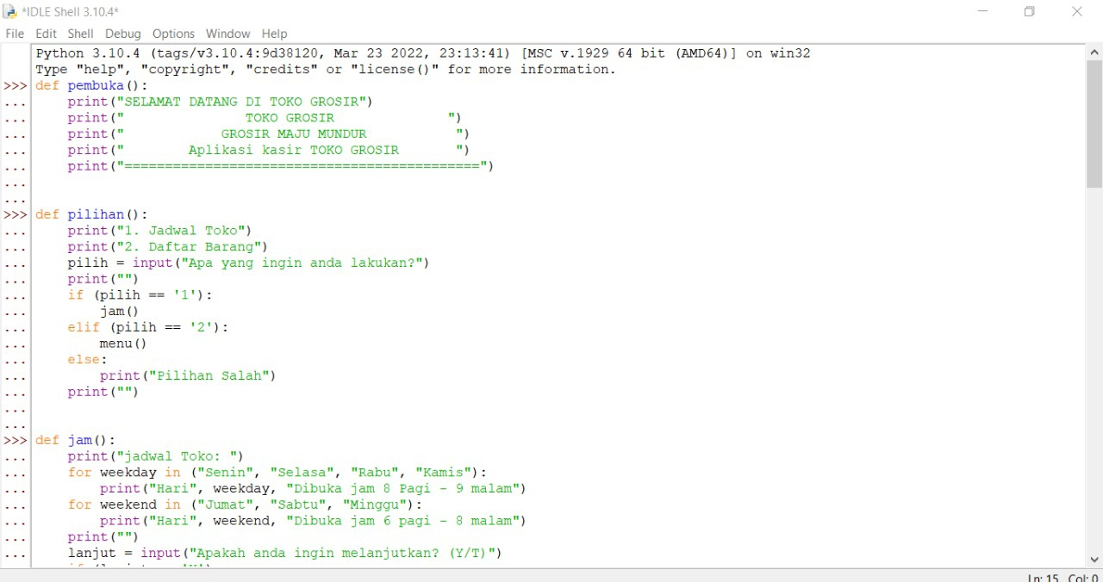

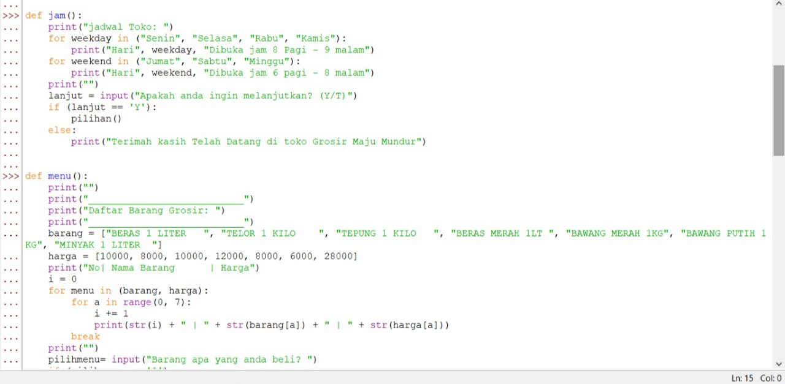

**SOURCE CODE**

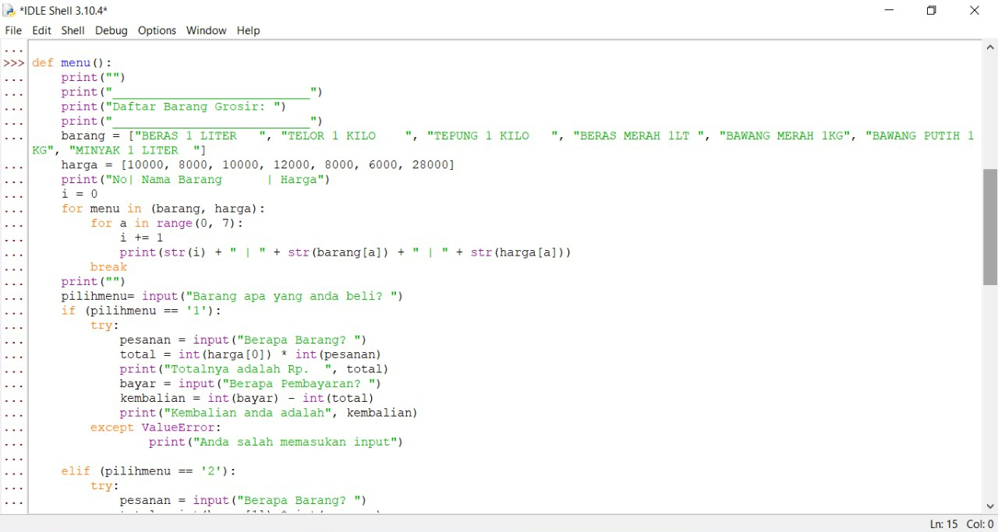

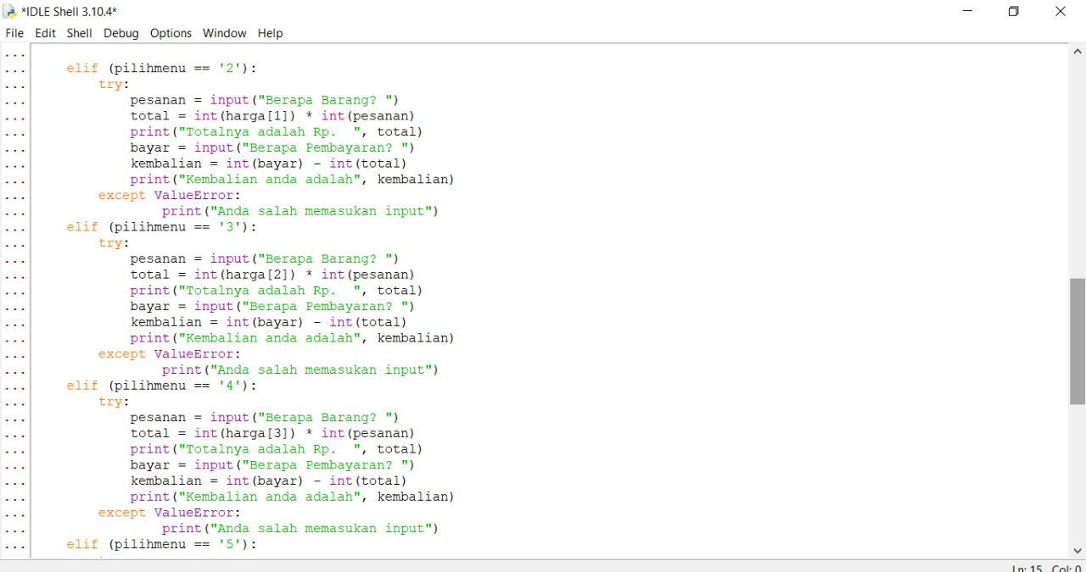

**SOURCE CODE**

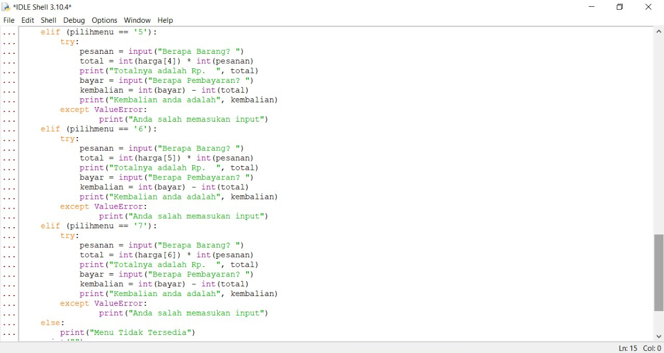

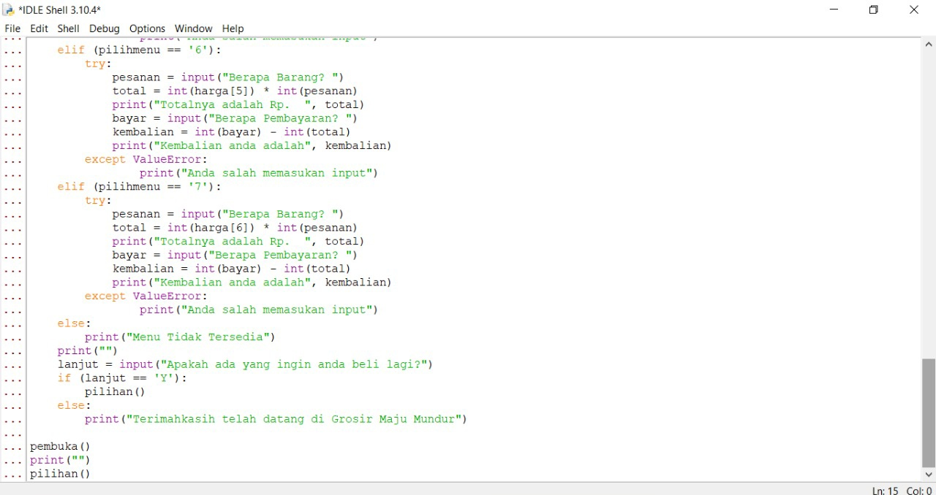

**SOURCE CODE**

**OUTPUT**

First input the number.Then will come out and the next step is look to choose the choice.

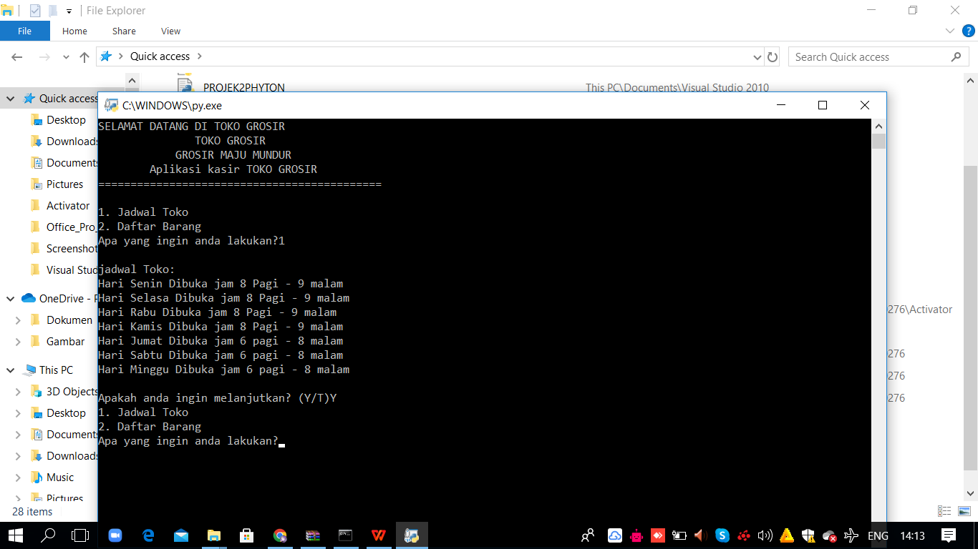

If user choose number ‘1’ it would be appear the opening hours of Wholesaler



**OUTPUT**

If user choose “Y” it would be back to the menu or if user choose T it would be end the program.



If user choose ‘2’ it would be appear the menu of Wholesaler App.

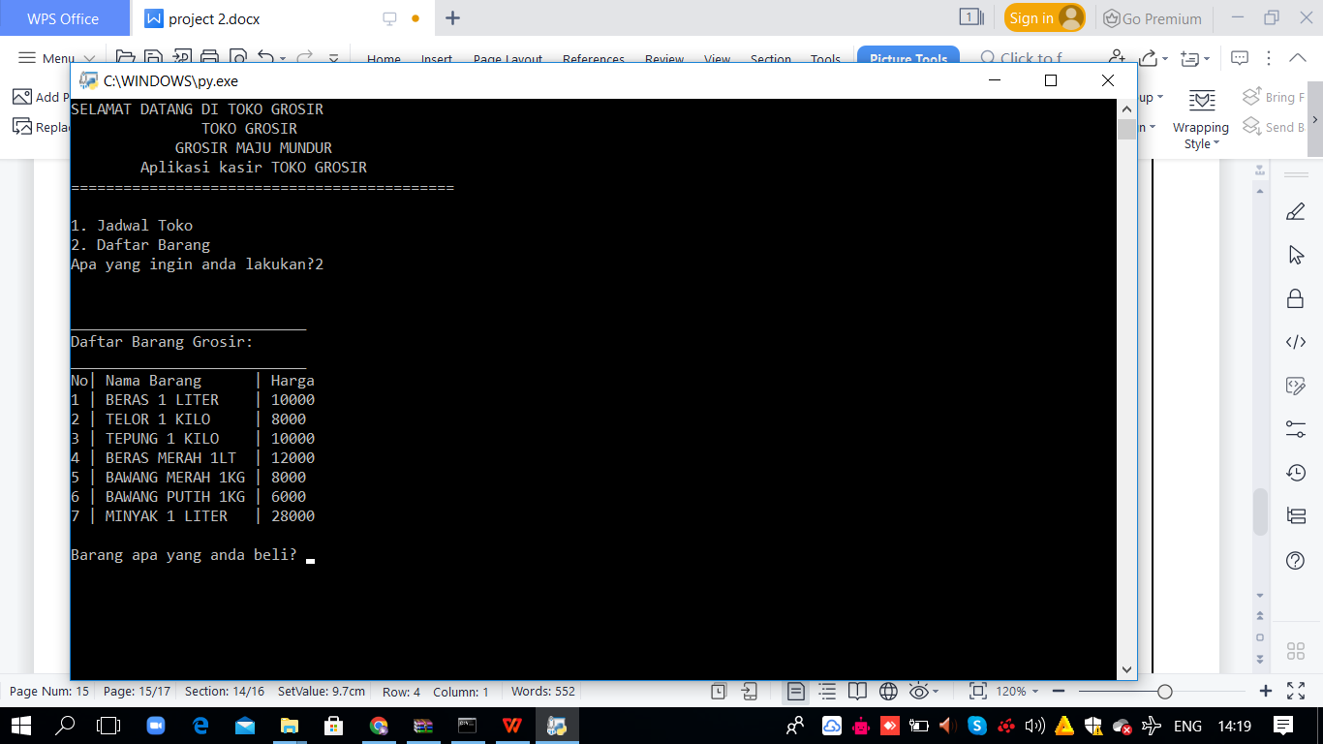

After user choose ‘2’ user input the food that user want to order, after that user input the total of the order and the price will appear.Next user input the money that user will give to pay and the program will show the change.

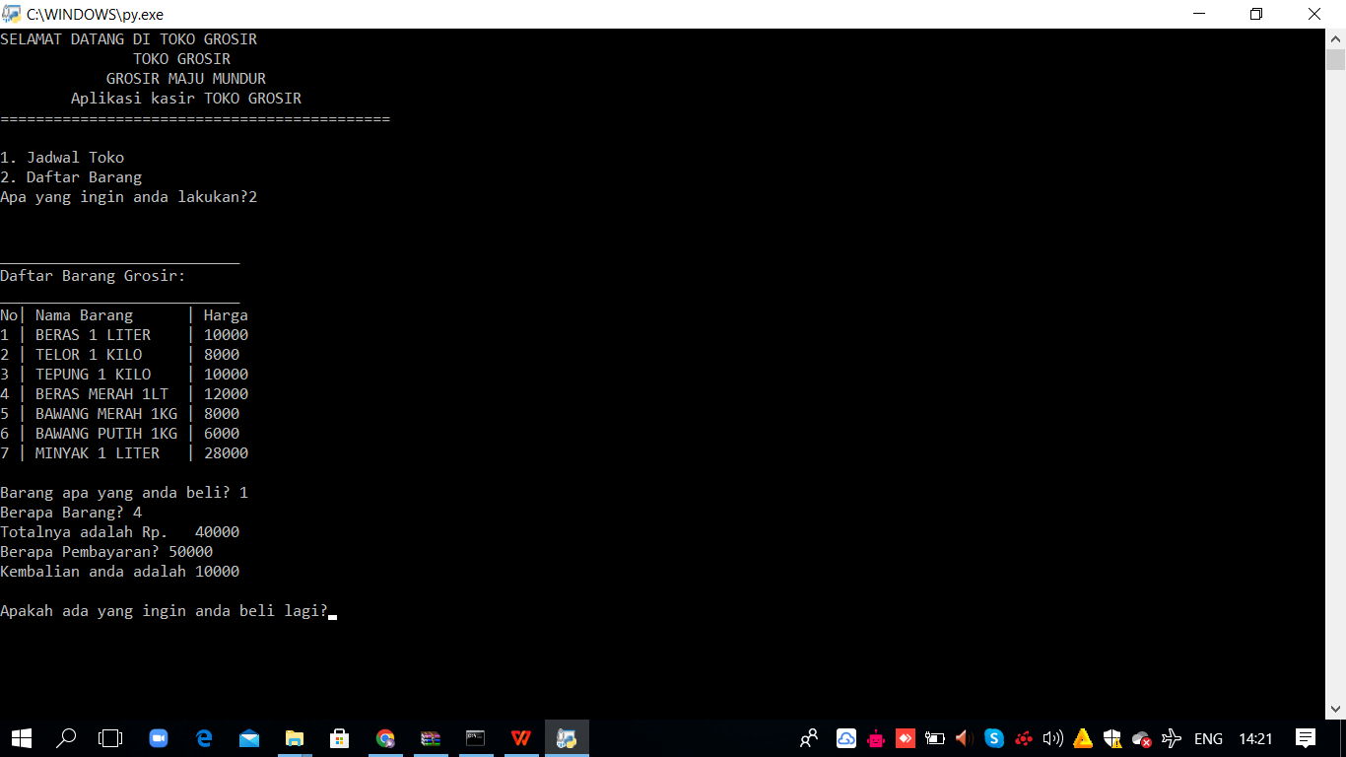

If you have already purchased you can choose 'Y' if not 'T'

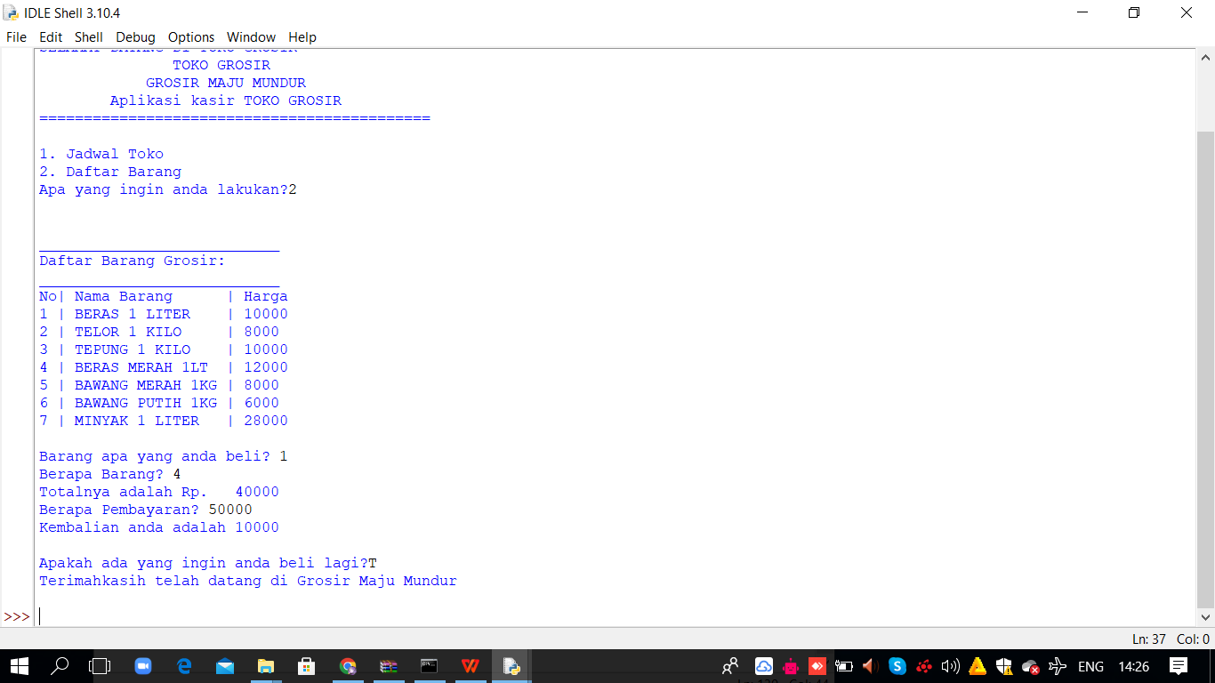

**OUTPUT**

**CONFIGURATION**

**Operating System :** Windows 10

**Hardware :** Laptop

**Software :** Python (Source Code)

WPS OFFICE (Project Report)

|  |  |  |
| --- | --- | --- |
|  | **PROJECT FILE DETAILS** |  |
| **NO** | **FILE NAME** | **Remarks** |
| 1 | Project2.py | David Julian Ernestine  Isaac GIdeon Simamora  Muhammad Rafi Aulia |
| 2 | Project2.doc | David Julian Ernestine  Isaac Gideon Simamora  Muhammad Rafi Aulia |